

EMPOWER

Exploring Mythical POrtsmouth's WEllbeing jouRney

Contents

Introduction 2

‘Experiencing Portsmouth’ Game Overview 2

High Concept 2

Genre 2

Target Audience 2

Platform 2

Unique Selling Points 2

Gameplay Overview 3

Game World Overview 4

Real World Gameplay 4

Mapping to the Hero’s Journey 4

Collaboration Overview 4

Player Objectives 5

Authoring Module Overview 5

Commercialization 5

Comparative Games 6

Document Author 6

# Introduction

The ‘Experiencing Portsmouth’ game provides new students and University of Portsmouth applicants an opportunity to reflect on the life changing experiences of studying at the University of Portsmouth. The game is designed to offer opportunities to share experiences and thoughts in a safe and supportive collaborative environment. As potential pitfalls and issues are raised routes to support and help are provided.

Although this particular implementation of the game is targeted at University of Portsmouth students and future students the underlying structure and gameplay may be applied in other contexts. For example, this could provide support within the PONToon project.

The EMPOWER application comprises three distinct components:

* Authoring Module
  + For creating game content
* Play Module
  + Single player game
* Collaboration Module
  + Online environment for sharing user authored experiences within the game
  + Peer to peer sharing of experiences

The novel use of the Hero’s Journey in the game and also user content are expected to result in significant research outputs.

The finished product is expected to offer commercial opportunities.

# ‘Experiencing Portsmouth’ Game Overview

## High Concept

Reflect on future university life events in the context of the Hero’s Journey with help signposted and opportunities for collaboration.

## Game Genre

***3rd Person, Turn Based, Computer CCG RPG for Well-being***

‘Well-game’ role playing game for promoting and supporting wellbeing.

Turn based, strategy (collectable) card game mechanisms.

Pervasive and locative play on some platforms.

## Target Audience

Applicants for University of Portsmouth courses.

University of Portsmouth students, in particular newly arrived at the start of their first year.

## Platforms

PC, browser, mobile phone & tablet (Android and iOS)

## Unique Selling Points

* Multiplayer use of the Hero’s Journey with players experiencing and asynchronously sharing and comparing their individual journeys in a mix of fiction and gameplay.
* Engaging well-being support through a CCG RPG game with help cards generated by the players journey through the game offering concrete, specific ways of dealing with problems.
* Authoring module enables the underlying technology to be used in many different situations to support well-being.
* Linking real world inspired events to a role playing game enables players to explore the consequences of different behaviours.
* Academic progress is simulated to encourage productive approaches to university work.
* Re-imagining of Portsmouth as a magically real mythical city for metageographical exploration.

## Gameplay Overview

Players move their character through Portsmouth themed locations encountering ‘events’. Each event has a number of different outcomes or ‘consequences’ that can be invoked by the player choosing from a context sensitive selection of ‘actions’. Events include, but are not limited to, interactions with non-player characters. The characters, events, actions and consequences are presented as cards, similar to collectable card games like Magic the Gathering[1], presented in front of a location backdrop image.

Note that by having the player control a (customised) character they are able to role play different personalities and/or genders at a distance. The hope is that this will encourage empathy.

In addition to pre-authored consequences and actions the player may also author their own thoughts on the situation in a quest journal (presented as a deck of cards?). The journal entries may comprise prose, poetry, quotes or simply lists of words.

The look of the player character may be customized. A simple set of attributes may also be customised:

* Mental (equivalent to ‘Intelligence’ in existing RPGs)
  + Maps onto academic activities like attending lectures and completing coursework
  + Success or failure
* Physical (equivalent to ‘Strength’ in existing RPGs)
  + Eating well, exercising, taking the stairs instead of the lift
  + Sickness, obesity, insomnia…
* Spiritual (equivalent to ‘Mana’, ‘Charisma’ or ‘Wisdom’ in existing RPGs)
  + Taking some calm time for reflection, mindfulness
  + Stress, confusion, worry…

These are presented as ‘Dimensions of Well-being’. They are represented on screen by simple bars (or similar) that vary along a number line that stretches from negative through neutral to positive.

Time in the game is divided into turns, each representing a week (a fortnight?) at university during which a single event can occur in a single location. Each teaching block is represented as a quest. At the end of each quest the player receives a progress report and has the opportunity to adjust (level up) their attributes. Attribute adjustments are made to the size of the bars, increasing the negative or positive lengths. Additional options (events, actions, consequences) become available with particular attribute profiles. For example, a positive increase in ‘Physical’ may open up a ‘joins university football team’ event. A negative increase in ‘Physical’ enables more consumption of alcohol without sickness.

At the end of a game the player has the opportunity to output (as a .pdf or equivalent) their in-game journal. This contains a summary of events, consequences, actions, signposted sources of help and player journal entries.

Note that player characters can both thrive and also crash and burn depending on the choices they make through the game. At any point in the game the player can ‘rewind time’ in order to experiment with different journeys thought the game. ‘Help’ cards provide the player with real world ways of addressing the problems their player character encounters.

## Game World Overview

The game is set in two versions of Portsmouth corresponding to the ‘ordinary world’ and ‘special world’ of the Hero’s Journey. In the game these are presented as ‘Real Portsmouth’ and ‘Mythical Portsmouth’. There may be both Real and Mythical versions of the same location.

Locations are represented by both art and prose. The art includes photos, both un-doctored and edited (‘Photoshopped’).

Real myths and historical events (the bombing of Portsmouth Guildhall) merge to create a magically real version of Portsmouth for the Mythical version of Portsmouth. Where no real myths exist they are invented.

## Real World Gameplay

Pervasive, locative gameplay may be incorporated in addition to gameplay within the game world on computers, tablets and phones. For example, the player may record activities they perform in the real world that will then affect their character:

* Complete some coursework, increase Mental attribute
* Visit to the gym, increase Physical attribute
* Meditation, increase Spiritual attribute

Although player can clearly ‘cheat’ these, it does not really matter. They are still able to see the results of these behaviours, which is what the game is focussed on.

An optional goal for the game may be to have mobile versions of the game able to automatically (ambiently) track player location and reward the player appropriately. For example, the player might set a quiet, thoughtful spot where they recharge their player character’s Spiritual attribute.

## Mapping to the Hero’s Journey

As well as mapping the game world to the Hero’s Journey the interactive plot of the game is also mapped to the Hero’s Journey. Key events in a typical student journey through an undergraduate course are mapped onto the key events in the Hero’s Journey. The plot structure may diverge after each stage is passed, but will converge again for the next stage.

The player character’s attributes affect the choices (‘actions’) available to the player during the journey. Note that the game is designed to be replayed in order to fully explore consequences using the ‘rewind time’ feature.

## Collaboration Overview

Each player’s experience of the game and the notes they make in the journal are private. However, they may contact other players (via email) to enable sharing.

Anonymous sharing is enabled by allowing players to upload their personal journal comments to the online Collaboration Module. Each set of comments are attached to a particular location and event and are added to the online store for that location/event. Each location/event store shows a word cloud of all submissions. Note that this enables the anonymising of uploads since words (i.e. names) that do not occur often are not shown. Also, although a word cloud gives the mood of a location/event it does not give specific phrases. The phrase ‘I hate you’ would be word clouded to ‘hate’, suggesting a mood, without explicitly attacking anyone.

The sharing of journaled experiences opens up opportunities for groups of students and staff to share experiences and explore different routes to well-being. This could also be a way to provide data for research.

## Player Objectives

Short term

* Keep well-being attributes positive
* Navigate locations
* Interact with events and non-player characters

Medium term

* Complete actions in the current location (including journal writing)
* Progress to the next stage of the Hero’s Journey
* Upload journal entries
* Share experiences with peers

Long term

* Complete the Hero’s Journey/undergraduate course
* Print the player journal

## Authoring Module Overview

The authoring module enables the creation of:

* Decks of character, event, action and consequence cards
* Locations
* The game logic links between the cards

Specific functions are:

* Embed images
* Attach text and customize layout/font
* Narrative design (conditional links between events)

Once authoring is complete the game content can be exported to the play module. The finished play module is stand alone, but links to the online collaboration module.

# Commercialization

The Authoring, Play and Collaboration suite of modules enable the creation of different game scenarios modelled on the Hero’s Journey. There are many ways the product and individual scenarios could be monetized, including:

* Charge a one off fee and supply the three modules
* Charge a monthly fee and host the collaboration module, buyer to create their own scenarios
* Charge a fee to author a play module and then a monthly service charge for hosting the collaboration module
* Charge a one off fee for authoring the play module and do not host the collaboration module
* Make the whole project open source, but charge for assistance in implementing scenarios
* Philanthropic sponsorship
* In-product advertising

Scale the charges dependent on how many users.

Embed the University of Portsmouth identity throughout the product for promotional purposes.

# Comparative Games

Alter Ego, a 1986 game from Activision that leads the player through a whole life, making decisions on key life changing decisions. Play Alter Ego here: https://archive.org/details/msdos_Alter_Ego_Male_1986

The Sims. A virtual dolls house in which the player controls the lives of player characters. www.thesims.com

Magic the Gathering. A collectable card game available both on paper and online. Useful for informing the design of the cards. http://magic.wizards.com/

Dungeons and Dragons, both the paper version and computer versions like Baldur’s Gate. A good model for role playing elements. http://dnd.wizards.com/

Articy:Draft: professional game design authoring package from Nevigo. Useful for informing the design of the authoring module. May be possible to use this instead of, or in conjunction with, an authoring module. <http://www.nevigo.com/en/articydraft/overview/>

Pokemon Go is an excellent example of locative play, though more sophisticated than we are likely to attempt. <http://www.pokemon.com/uk/pokemon-video-games/pokemon-go/> & <http://www.pokemongo.com/en-uk/>

# Authoring Module

At the heart of the authoring module there are a series of spreadsheets for the ‘cards’ that the game is played with.

The data for these spreadsheets might be entered using a series of forms, each containing fields for the card parameters.

Once the file formats for the graphics (resolution, file type) are set these can be collected and placed in appropriate folders for the game to use.

Being able to run the game and test the Event currently being worked on is vital for streamlining the production. That the game can be launched from within Authoring Module is important. The tighter and faster this feedback loop runs the less likely there will be bugs creeping in.

# Play Module

## Screen layout

### Play screen with location only

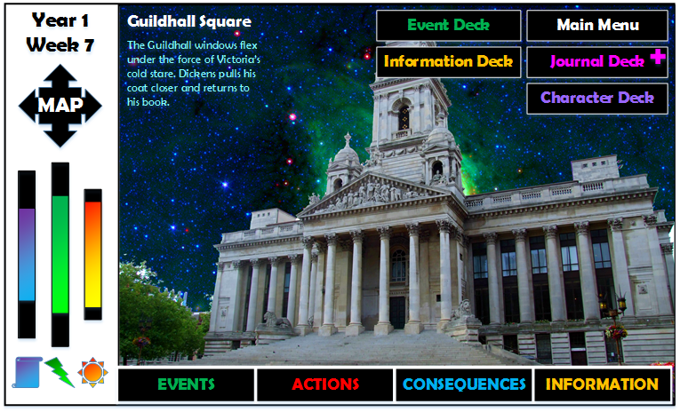

### Play screen with cards

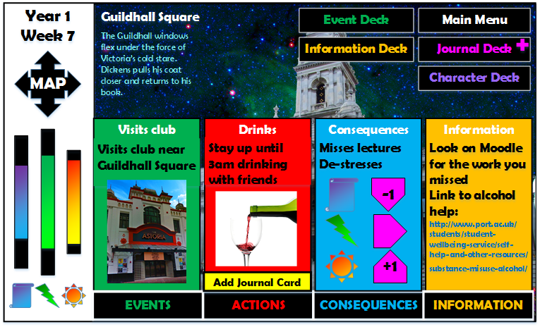

### Map screen

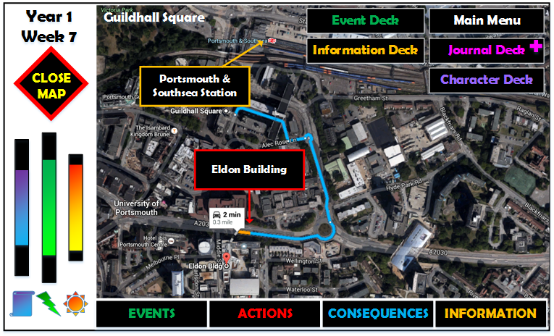

## Card system

Information and player choices are presented on ‘cards’. These are simply rectangular windows that can contain any of the following:

* Text
* Graphics
* Hyperlinks to other cards
* Hyperlinks to external sources such as web pages
* Attribute and game modification triggers

The layout (position) of text and graphics should ideally be flexible.

A standard range of fonts can be selected.

The background may either be a solid colour or can be an image.

### Card type

Each card belongs to a particular card type, which determines where it appears on the screen and how it may behave.

* Event Card - ECD
* Action Card - ACD
* Consequence Card - CCD
* Information Card - ICD
* Character Card - CHR
* Journal Card - JOU

### Text

The text on cards can be scene setting ‘flavour’ text or can be related to the game’s plot. The text may contain hyperlinks to other cards or external sources.

Text is placed in predefined windows (text box) and may wrap. If text overflows from the text box and scroll bar appears.

### Graphics

Rectangular 2D bitmaps, with transparency. However, as a stretch goal, might be animated (simply animated gifs?).

### Buttons

Graphics with ‘clicked’ (button down) versions when selected. These may be hyperlinks or triggers and more than one event can be attached to a single button.

For example, an ‘Add Journal Card’ button opens up a Journal Card the player can enter text into. The Journal Card contains a ‘Close’ button that saves and closes the Journal Card.

### Card links

Hyperlinks to other cards. These might be additional cards loaded onscreen with the current card still visible; or might load a card to replace the current card.

These links may be conditional. Conditions should include any of the following:

* Player Character attribute levels (maximum or actual)
* Time (in the game world)
* Other (pre-requisite) cards have been ‘completed’ (accessed and acted upon)
* Location
* Player Character Class
* Player Character Gender
* Player Character Partner

### External source links

Typically links to a web page that is opened in a browser window (using the default browser on the device).

### Gameplay triggers

Additionally cards may trigger gameplay events, such as altering character attributes or enabling game-world or plot changes. For example, changing available the range of available Action Cards.

‘Open Map’ is a gameplay trigger that opens the Map Screen.

## Decks of Cards

Although some cards (Event Cards, for example) appear singly onscreen, sometimes more than one card appears on screen as a Deck that the player can shuffle or step through.

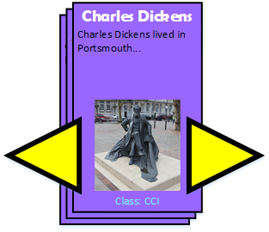

Deck of character cards with ‘step through’ buttons.

### Action Card Deck

Action Cards will often initially appear as a Deck of two or more cards that the player may step through, one at a time, while selecting their preferred action in response to an Event Card.

### Event Card Deck

Contains completed Event Cards. Players may choose Event Cards from this deck to replay, though note that the results of the replay do not count towards ongoing progress in the game and do not affect current attribute levels. This is just to enable players to explore the Consequences of different Actions.

### Information Card Deck

Contains a complete set of Information Cards. Information Cards that have been already viewed during the game can be sorted to the top of the deck, in the order in which they appeared, with the most recent at the top.

### Character Card Deck

Players can sort through cards of all the characters they have encountered and also access their own player character.

### Journal Deck

Contains all of the player’s Journal Cards. Note that in addition to Journal Cards being added using the link on Action Cards, there is also an ‘Add Journal Card’ button on Journal Cards that enables the player to add more Journal Cards. Existing Journal Cards may also be edited.

## Event Cards (ECD)



Plot events are described. The player may respond to these by selecting an Action Card.

Event cards are normally linked to one or more locations and only appear at these locations. The specific Event Card that is revealed at a location may also be linked to the Maximum Value of the player character’s attributes. There is an expectation that if a player has concentrated on developing one attribute more than the others then they will be making choices to keep this attribute ‘full’ (i.e. keeping the Actual Value high). If they are not then the available Actions suited to the Event may be restricted.

Event Cards are automatically revealed at locations. They are selected by the following steps:

1. Event card is connected to current location
2. Event card matches player character class
3. Pre-requisites are all met
4. Where there are attribute value prerequisites the Event Card with the highest value is selected
5. Where there are more than one Event Card that matches these criteria one is selected at random

One or more Action Cards are linked to each Event Card.

Note that Event Cards may be used to explicitly signal which stage of the ‘Hero’s Journey’ the player has reached.

### Properties

**Card Number**

Reference number

**Name**

Unique name

**Description**

Text that appears on the card.

**Action Card links**

List of all Action Cards that can be used to respond to this event. Note that some of these have prerequisites that mean that for a given event they may not be available. For example, an Attribute Prerequisite may prevent an Action Card from being displayed in response to an event.

**Character Card links**

List of Characters that are linked to this event. Note that once a character has appeared they are added to the player’s Character Deck.

**Time prerequisites**

The week range in which the event may occur. Can just be a single week.

**Location prerequisites**

A list of locations where the Event may occur. May be locked to a single location or a large number of locations.

Note that if a number of different events are linked to a single location then prerequisites, such as a Class Prerequisite, may determine which of the events are displayed to the player. For example, a set of five event cards may be attached to the same location, but which one is played is determined by the players’ stated class.

**Attribute prerequisites**

Minimum attribute values that must be met before the card is shown.

Note that this gives the opportunity to restrict particular events. For example, have an Event that occurs in the final teaching block in year 3 that is only unlocked if the player spent all their experience points on a single attribute when levelling up (see section on the Attributes System).

**Gender prerequisites**

Some Events may be only available to a particular player character gender. There is an assumption that if this field is left empty then there are no restrictions.

**Partner prerequisites**

Some Events may be only available to player characters with particular Partner preferences. There is an assumption that if this field is left empty then there are no restrictions.

**Class prerequisites**

Some Events may be only available to particular classes. There is an assumption that if this field is left empty then there are no restrictions.

**Event Card prerequisites**

A list of any Event Card(s) that must have previously been played before this one is revealed.

## Action Cards (ACD)



A selection of one, two or more Action Cards are available for the player to choose from when responding to an Event Card. These enable the player to grow their character and progress through the game, their journey and the plot.

Action Cards may have attribute or Event Card pre-requisites: they may only be available if certain attribute conditions are met and/or named Event Cards have been completed. An important attribute of each Action Card is the Year(s) and Week(s) of game time when they may occur.

Only a single Action Card can be selected to respond to the current Event Card.

One or more Consequence Cards are linked to each Action Card.

Action Cards always have an ‘Add Journal Card’ button to enable the player to respond and reflect on their actions.

## Consequence Cards (CCD)

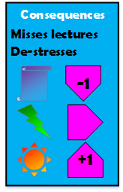

When an Action Card is selected one or more Consequence Cards are automatically triggered.

Other attribute or completed Event Card conditions may determine which Consequence Cards are displayed.

If more than one Consequence Card is triggered they are displayed as a Deck that the player can flick through.

Consequence Cards can increase/decrease attributes when they are triggered. These increases/decreases may be specified on the card.

## Information Cards (ICD)



Information Cards can be linked to any other cards or locations and may also have pre-requisite attribute and/or Event Card conditions. They are typically advice cards that appear as the player progresses through the game.

They might also contain background information on locations, characters and the plot. Note that they are not required for moving through the game, but often give additional information (and web links) that relate to the ‘real world’, and will often lead to resources outside the game world.

These cards have a distinctive look that separates them from the other cards, which are all in the fictional game world.

## Character Cards (CHR)

Information on player and non-player characters is given on Character Cards. The player can access non-player Character Cards only after they have met that non-player character. In this way progress through the game is demonstrated through a growing deck on Character Cards.

The player Character Card contains information on Attributes and progress through the game. The player may also upload a photo to this if they wish. This photo is only available locally to the player and is not automatically shared.

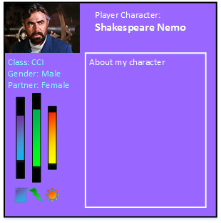

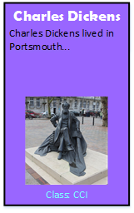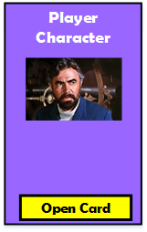While in the Character Card Deck the player character is collapsed down to the same size as the other character cards:

## Journal Cards

Journal Cards are available for the player’s reflections on their journey and the choices they are making.

Each Journal Card has a single text box and optional image box (the layout changes to accommodate an image if they choose to add one). Images and text are not automatically shared.

Players are able to upload text to the Collaboration Module.

Players are able to share Journal Cards containing text and/or images with other players, on an individual basis. They cannot ‘broadcast’ to groups of other players and cannot share information anonymously with other players.

On completing the game players may export their Journal Cards as a .pdf file that they can share and print.

## Location (LOC)

A location comprises a background graphic with a title and some optional descriptive plot or flavour text. Each location is associated with one or more Event Cards.

Locations may also contain non-player characters, who may feature in the plot or flavour text of the location. When these characters are first encountered they are added to the Character Card Deck. One or more Character Cards could appear in the location when the player character arrives: the player uses a ‘Close Character’ button to remove the non-player character card, which can then be accessed in the Character Card Deck.

There are two types of location: Real (R) and Mythical (M). The player may choose which type of location to enter. Note that if a single geographical location has both a real and a mythical version then these are treated as two separate locations. In the game the player may choose to visit Eldon Building (R) or Eldon Building (M), each of which has a different location number.



## Map Screen functionality

The Map Screen enables the player to select locations to move to and shows previously visited locations. Note that many locations have both Real (R) and Mythical (M) versions. These are both listed.

When the player is at a location the following are visible:

* Previously visited locations
* Adjacent mythical and real locations they can travel to (these are clickable and load the new location)
* A line depicting the route they have taken between previous locations

An ‘adjacent’ location is defined as any unvisited version (real or mythical) of the current location and also any other locations that may be reached without passing through an intermediate location.



## Attributes system

The attributes are measured in Experience Points.

There are three attributes that in this game represent:

* Mental wellbeing
* Physical wellbeing
* Spiritual wellbeing



There is a Maximum Value for each of these that varies when levelling up during the game, represented by the length of the attribute bars. The Actual Value varies during play, limited by the Maximum Value. For example, a player character increases their Physical Actual Value by visiting the gym frequently, but then eats poorly and the Actual Value decreases (the coloured portion of the Physical Wellbeing bar).

### Levelling up Attribute Maximums

At the start of each Teaching Block (Week 1 and Week 13 of each year) the player is given the opportunity to increase the Maximum Value (length) of their attribute bars. In this way they can affect the Action Card choices available for responding to Event Cards.

Starting value of each Attribute Maximum at the beginning of the game is 10 experience points. Additionally the player has 5 experience points to distribute between the three attributes. These adjust the starting Attribute Maximum Values.

The Actual Attribute Value at the start of the game (the start of year one, week 1) is 8 experience points in each attribute bar.

The player then adjusts the Maximum Values of the three attributes at the start of the following weeks:

* Year 1 Week 13
* Year 2 Week 1
* Year 2 Week 13
* Year 3 Week 1
* Year 3 Week 13

At each of these times the player has 5 experience points to distribute between the three attributes’ Maximum Values.

* Year 1 Week 1 - 35 experience points total
* Year 1 Week 13 - 40 experience points total
* Year 2 Week 1 - 45 experience points total
* Year 2 Week 13 - 50 experience points total
* Year 3 Week 1 - 55 experience points total
* Year 3 Week 13 - 60 experience points total

The highest possible Maximum Value of a single attribute is 40, if the player ‘spends’ all their experience points on the same attribute each time they level up. The lowest possible level is 10. An even distribution gives each attribute a Maximum Value of 20 at the end of the game.

A score might be displayed on the Player Character Card of the relative amounts of experience earned in the three attributes during the game (NB attribute losses are ignored, only the gains are counted in these indicators). As the attributes distributed by Consequence Cards are added to ongoing scores the player can see if they are favouring one attribute over the others. See the version of the attributes indicator below:



The line to the left of the Actual Value bar indicates the attribute Relative Value being earned. This gives the player an indication of how they are behaving over the whole of the game, rather than the Actual Values that are constantly fluctuating. At the start of the game the Actual and Relative attribute values will be very similar, but later in the game may diverge. May be that this needs play testing to see if the variation between Actual and Relative Values is significant.

### Mental Attribute



Equivalent to ‘Intelligence’ or ‘Wisdom’ in existing RPGs.

Maps onto academic activities like attending lectures and completing coursework.

Measures of academic success or failure.

### Physical Attribute



Equivalent to ‘Strength’ or ‘Agility’ in existing RPGs. Also similar to Health, though in this game there is no death so there is no separate measure of Health, rather it is comprised of the three attributes: Mental, Physical and Spiritual.

Eating well, exercising, taking the stairs instead of the lift.

Linked to sickness, obesity, insomnia…

### Spiritual Attribute



This relates to the emotional state of the player. Note that this is distinct and different from Mental, which is connected to academic prowess. This is deliberate. A player may be happy (high score on the Spiritual Attribute) but not succeeding academically (low score on the Mental attribute).

Equivalent to ‘Mana’ or ‘Charisma’ in existing RPGs.

Taking some calm time for reflection, mindfulness.

Linked to stress, confusion, worry…

## Class System

The Class System is based on University of Portsmouth Faculties:

* Faculty of Creative and Cultural Industries
* Faculty of Humanities and Social Sciences
* Portsmouth Business School
* Faculty of Science
* Faculty of Technology

Which gives the following classes:

* CCI
* HSS
* PBS
* SCI
* TEC

The player chooses a class when they create their character at the start of playing the game.

## Game Time

The game is turn based and game time is indicated by the ‘Year’ and ‘Week’ given on the play screen. Each ‘turn’ is the player response to a single Event Card.

A single game spans the three years of a degree course, with 27 weeks in every year (induction week, teaching blocks 1 & 2 and an assessment period of two weeks). This gives 81 weeks of game time, and within each week one or two events.

The time is given as year and week:

YR1WK05 – Year 1, Week 5.

Week ranges may also be given. For example:

YR1WK1-YR1WK25 is the whole of Year 1.

The time taken to complete the game can be determined by setting the number of events that can completed in each ‘week’. Perhaps initially one event per week would work, should give a few hours of gameplay: 81 events taking 2 minutes each on average gives approximately 3 hours of gameplay.

If players are writing a lot in their journals then the play time increases significantly.

The number of different events available may be important in supporting replayability.

## Player Character Creation

The first thing the player does when starting the game for the first time is create a character. Note that there is more information attached to the player character than non-player game characters.

The player can choose the following:

### Character Name

Can enter any name they wish.

### Character Image

A series of pre-set characters are provided or the player may upload a small image of their own (either of themselves or whatever other image they wish). Note that this image is only stored locally and is not shared.

### Character Class

The player may choose to select the class associated with the faculty they are joining, but are not forced to do this.

### Character Attribute Values

The maximum values of attributes are fixed at the beginning of the game. The player has attribute points they can share around the three attributes.

### Character Gender

Choose between: male, female or intersex. GEM, GEF, GEI

### Character Partner

This is to determine the sexual orientation of the player character. The choices are:

* Male - PMA
* Mostly male - PMM
* Either male or female - PEI
* Mostly female - PMF
* Female - PFE

## Hero’s Journey

The hero’s journey is being used to add structure to the EMPOWER version of the game.

In the diagram below three players are each on their own Hero’s Journey. They are choosing to share some information with each other while also uploading some anonymised information to the collaborative online game page.

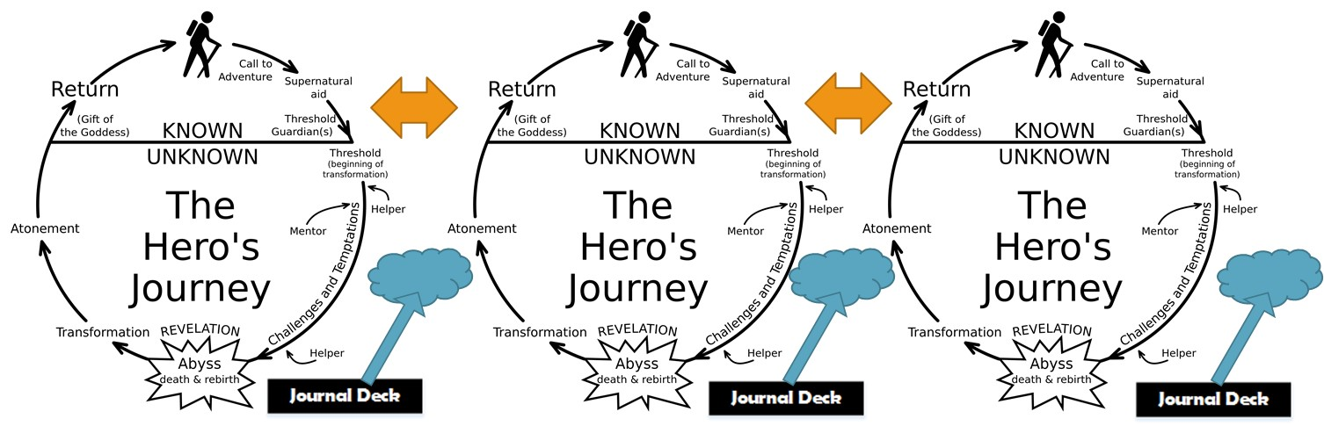

Each stage of the Hero’s Journey maps onto the events in the game.

1. The Ordinary World
2. Call To Adventure
3. Refusal of the Call
4. Meeting The Mentor
5. Crossing the First Threshold
6. Tests, Allies, Enemies
7. Approach to the Inmost Cave
8. The Supreme Ordeal
9. Reward (Seizing the Sword)
10. The Road Back
11. Resurrection
12. Return, with Elixir

# Collaboration Module

Each player’s experience of the game and the notes they make in the journal are private.

However, they may contact other players (via email or Bluetooth if they are in the same location) to enable sharing on a one to one basis.

Anonymous sharing is enabled by allowing players to upload their personal journal comments, recorded on Journal Cards, to the online Collaboration Module. Note that the sharing of images through the Collaboration Module is not supported, though players may share images individually.

Each set of comments are attached to a particular Action Card, Location and/or Event Card and are added to the online store (‘storage’ store, not ‘shop’ store). In this way each Journal Card has attributes of Action Card, Location and Event Card. The comments on each Journal Card may therefore be added to, or viewed through, a number of different database lenses:

* Action Card – all the comments associated with a particular Action Card
* Location – all the comments associated with a particular Location
* Event Card – all the comments associated with a particular Event Card
* Action Card & Event Card – all comments associated with that Action Card AND that Event Card
* Action Card & Location – all comments associated with that Action Card AND that Location
* Event Card and Location – all comments associated with that Event Card AND that Location
* Action Card & Event Card & Location – all comments associated with that Action Card AND that Event Card AND that Location

Each store shows a word cloud of all comment submissions that have the given set of attributes. The word cloud is like the word clouds produced by Wordle (<http://www.wordle.net/> NB Wordle does not work in Goodle Chrome). Note that this enables the anonymising of uploads since words (i.e. names) that do not occur often are not shown. Also, although a word cloud gives the mood of a location/event it does not give specific phrases.

The sharing of journaled experiences opens up opportunities for groups of students and staff to share experiences and explore different routes to well-being.

This could also provide data for research.

# Stretch Goals

## Locative Play

Event Cards may have a GPS location attribute that means they can be triggered in a particular location in the real world. These could be linked to university buildings to help familiarise students with the campus. Note that this locative GPS technology does not enable the identification of particular rooms within buildings, but would be accurate enough to locate landmarks around Portsmouth.

Collect a set of Location Cards by visiting places round Portsmouth.

## Real World Rewards

Students earn real world rewards (perhaps Print Credit?) by completing the game or gaining some sort of score.

## Localization

Provide different language versions of the game. Could be used to promote the University of Portsmouth overseas?

# Document Author

Dr Mark Eyles

Animation, Games and Enterprise Section Lead

Principal Lecturer  
School of Creative Technologies  
University of Portsmouth

Eldon Building  
Winston Churchill Avenue  
Portsmouth PO1 2DJ  
United Kingdom  
Telephone: 023 9284 5468

Skype: mark-eyles

Email: mark.eyles@port.ac.uk

Website: [www.eyles.co.uk](http://www.eyles.co.uk/)

1. See ‘Comparative Games’ section